I have an app and website called TidalTasks AI. It is an AI-powered calendar app made specifically for students.

Overall Idea & Objective
TidalTasks AI is a high-school and university-focused productivity app designed to help students manage tasks, events, and study schedules efficiently. The app uses AI to provide features like intelligent scheduling, task prioritization, integration with popular platforms like Google Calendar and Google Tasks, and personalized study recommendations. Its goal is to reduce stress, enhance productivity, and enable better academic and personal time management.

Key basic features:
- Users are able to create, edit, view and delete tasks, events and study sessions
- Set things like priority, recurrence, completion, along with basic fields like title, description, deadline, start time and end time
- Users are able to filter items by a variety of filters
- There are various displays including a dashboard with a priority section, tasks, events and study sessions that are upcoming, daily motivation, and more will be added soon
- There is a calendar view that has a way to see items categorized by type (task, event, study session) or in chronological order for the day
- There is a settings page where users can put information about themselves, their goals, as well as connect their account to google calendar, google tasks, todoist (coming soon), notion (coming soon)
- Users can choose which calendars to sync
- Users can also edit their google calendar and google tasks through the app by adding an item manually and then pressing a button to add to google calendar. When they update a task that came from google calendar, it also gives the option to update directly in google calendar, same logic for deletion.
- Study sessions customized with AI
- Notifications set by the user for any reminders, AI suggestions (coming soon)
- Conflict resolution if there are multiple things that have the same time and conflict in the schedule, allows users to either say they can do both at the same time to remove the conflict or move 1 to another time they choose, or a time that is recommended by the AI (coming soon)
- Time blocking (setting specific times reserved, i.e sleep, workout, school, etc) (coming soon)
- Analytics page with various details

AI Features:
The app is integrated with the gpt-4o-mini model.
- AI takes into context the user's profile, their schedule, and overall their personal needs
- There is a chatbot page, where users can ask it to add, update or delete tasks, events or study sessions, ask questions during study sessions, or do many other things on the app by just quickly typing. Eg (Create a study session from 5:00PM to 7:00PM today for a test tommorow) or simply help the user out, eg providing advice and taking actions on the schedule for example query "I am feeling very stressed as my whole calendar is almost full but I am finding more and more things"
- AI smart recommendations: Lets say the user added an event "Finals Math Test" scheduled 2 days later. A recommendation would be to create a study session in one of the user's free timeslots. (coming soon)

The app is deployed with vercel (soon, right now its localhost as its in development)
The app uses firebase features like firestore, authentication and cloud messaging

Dashboard
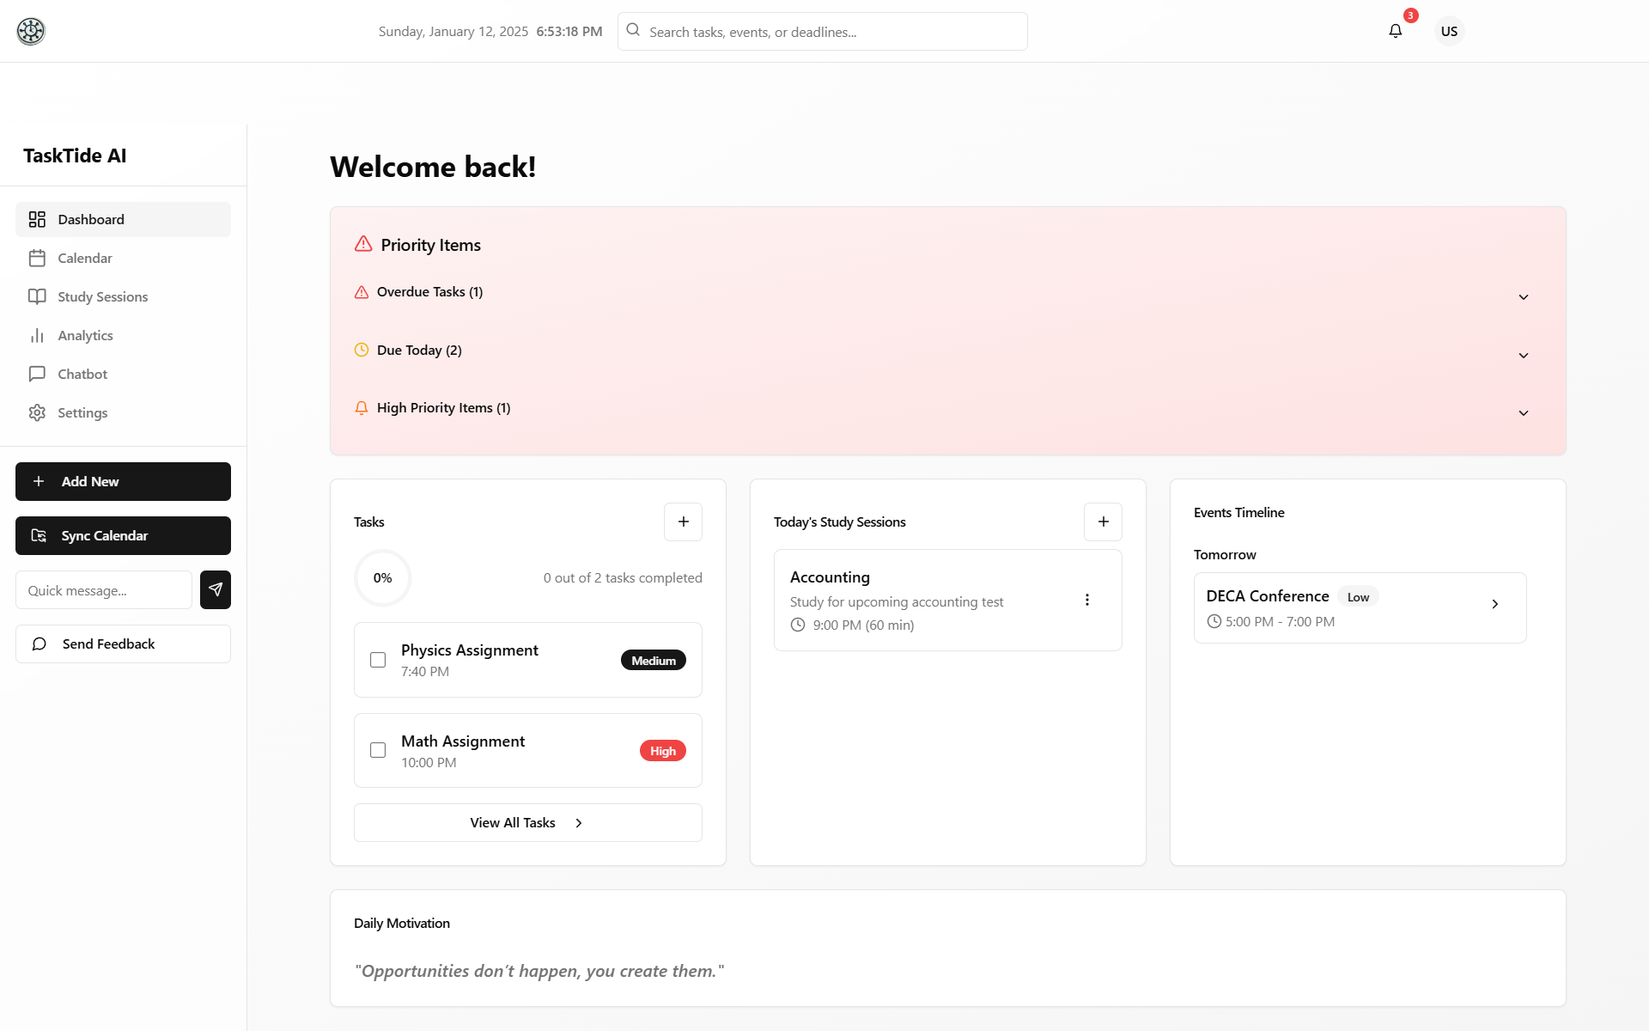

Tasks, Events and Study Sessions

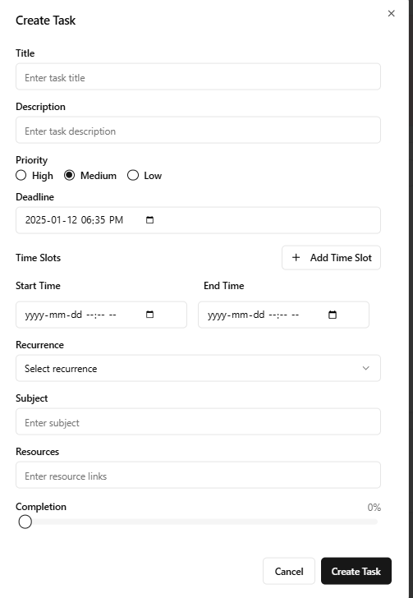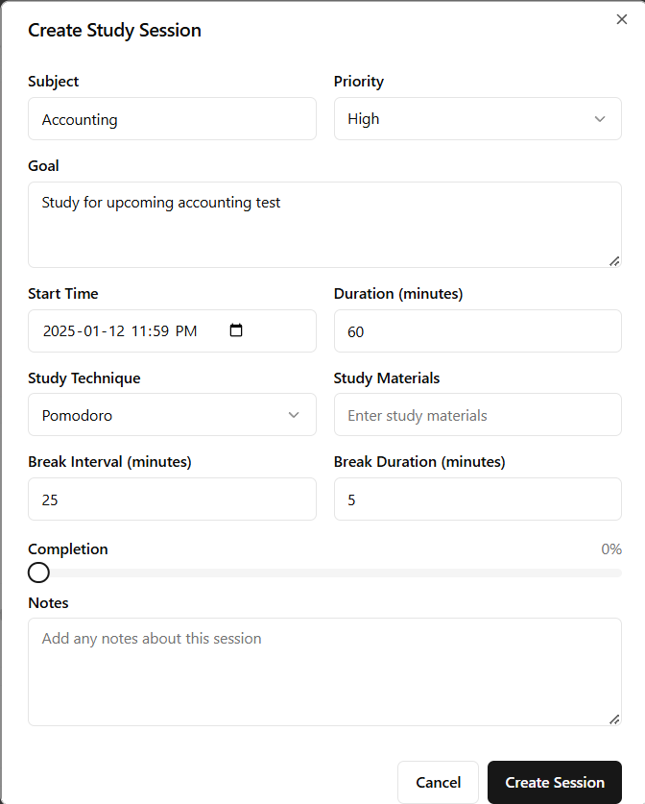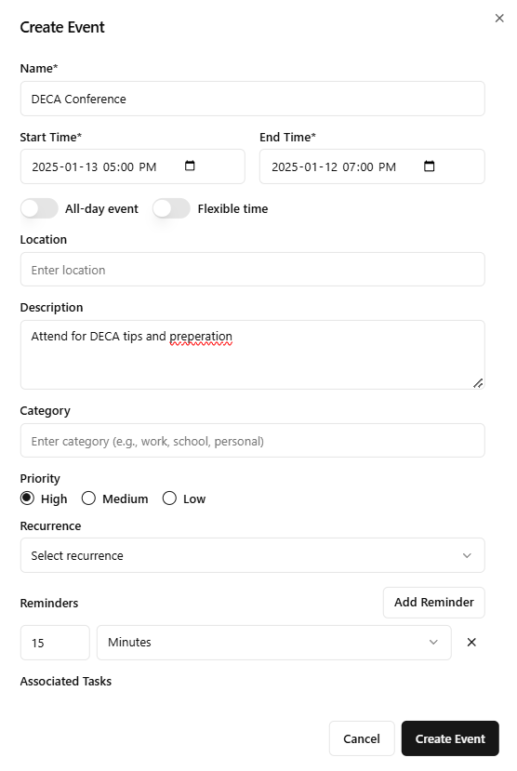

Calendar View
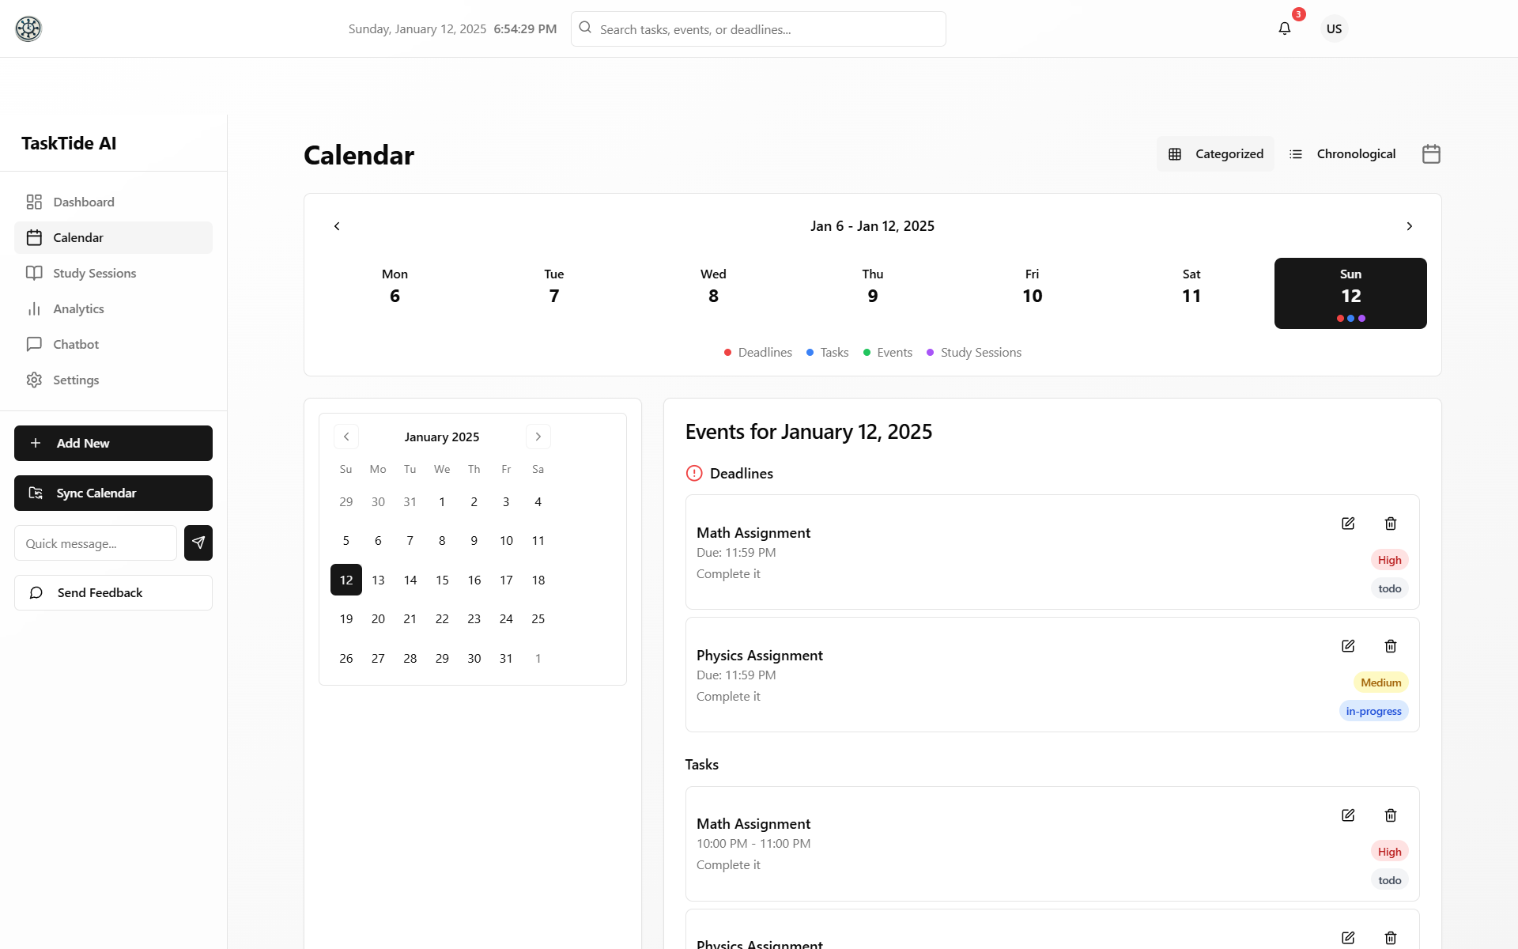
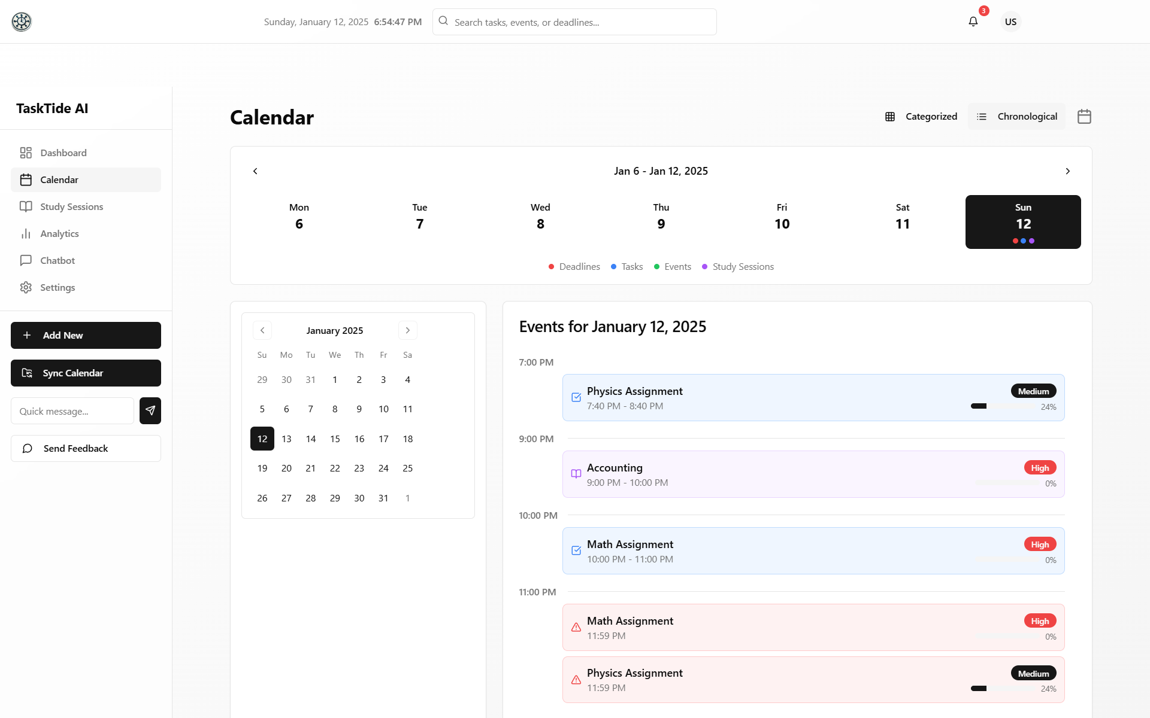

Study Sessions Page
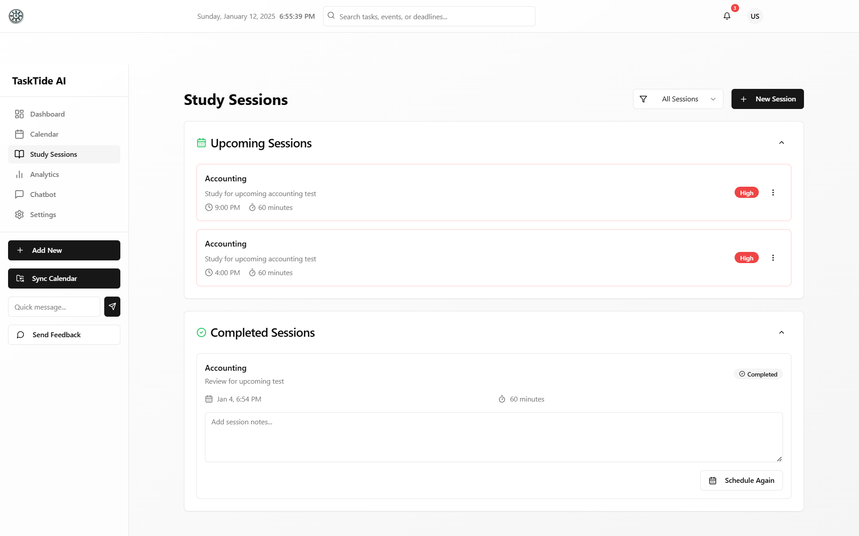
Analytics
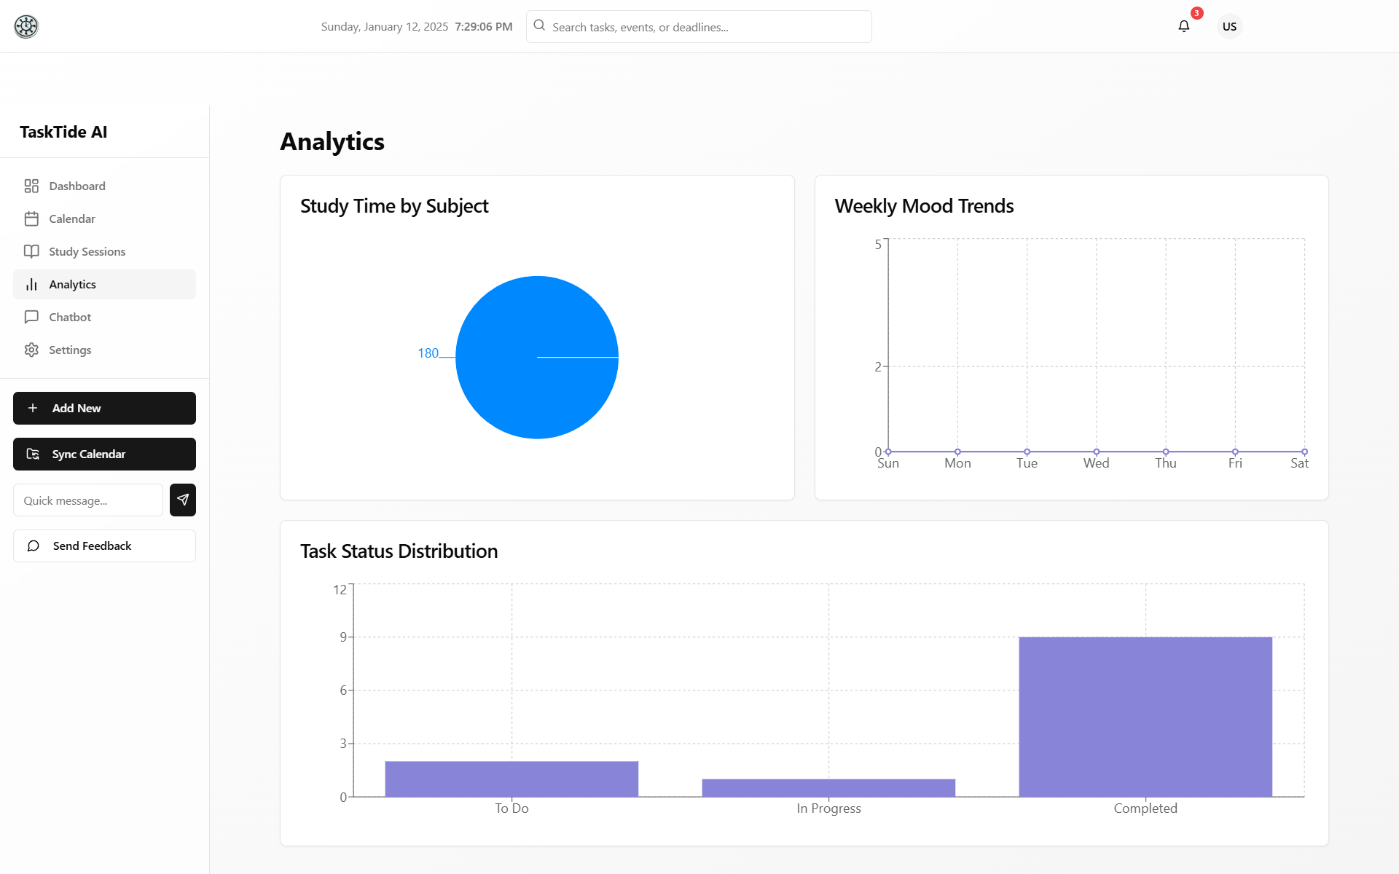
Chatbot
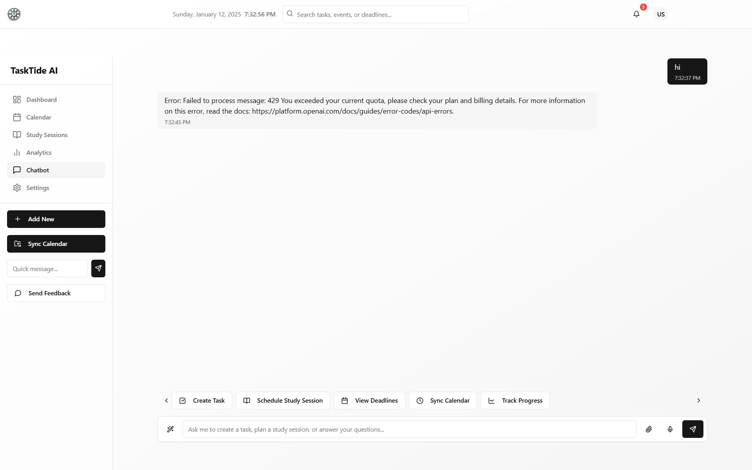

Settings
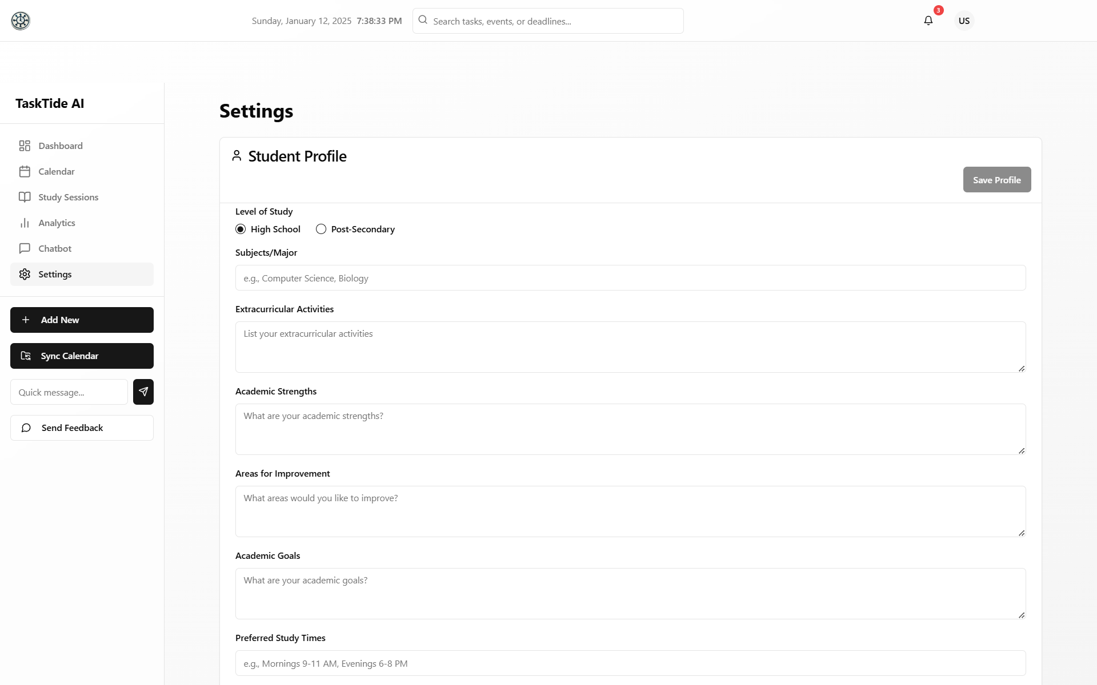
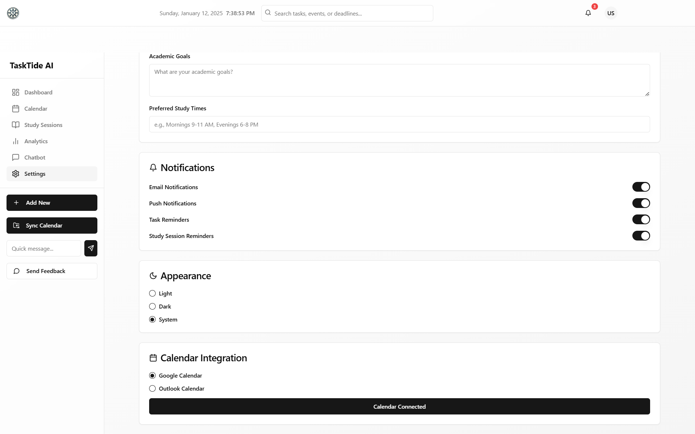
Sync Calendar
